

Coursework specification COMP1629 - 2025

Task 1 [20 marks]
Following a penetration testing engagement on a web application, several security issues have been identified and you are required to provide a detailed justification and explanation for each of these issues.
This should include the vulnerability criticality, the CVE, vulnerability details (e.g. this affects the system…. How? You need to research and explain), recommendations on how to fix with relevant links to information e.g. steps to fix.
The key here is that you need to understand what is the issue before you talk about it and provide your answer so please conduct supporting research on their nature of the vulnerability and potential impact.

Issue | CVEs | Vulnerability details | Recommendations, Fix, Links
JQuery (version 1.2) | What is the CVE | What is the vulnerability explain | Recommendations, fix (if any), relevant links to fix the issue explanation/steps if relevant etc
Stored XSS | What is the CVE | What is the vulnerability explain | Recommendations, fix (if any), relevant links to fix the issue explanation/steps if relevant etc
OpenSSL 1.0.2k | What is the CVE | What is the vulnerability explain | Recommendations, fix (if any), relevant links to fix the issue explanation/steps if relevant etc
Python 2.7.5 | What is the CVE | What is the vulnerability explain | Recommendations, fix (if any), relevant links to fix the issue explanation/steps if relevant etc
How to report and document: Within the technical section of your report you should have information per issue – the following issue template demonstrates how you could organise and present this within your report.
This is an example of how you could report a single vulnerability
Vulnerable Software Version Installed CVE CRITICAL/HIGH/MEDIUM/LOW/INFO
Issue identification e.g.  WEB 01 | What is the issue?  What is the host(s) affected? E.g. The software identified on 10.10.11.199 is out of support – expand – the client is paying you to explain 😊 How it can affect the system – expand! Justification of why you think this is the case e.g. I have identified you are running Windows XP and it is 2026 😊  Explain the issue, impact etc ideally no more than 20 lines….  Are there any fixes? How, explain and advise…  Are there any links to vendors or similar information?  Results  Here is where you include screen captures and details – keep it proportional to the issue you cover – don’t include many screen captures, make sure your evidence is focused and to the point!  Here is a Bad Example when reporting on a cookie related message  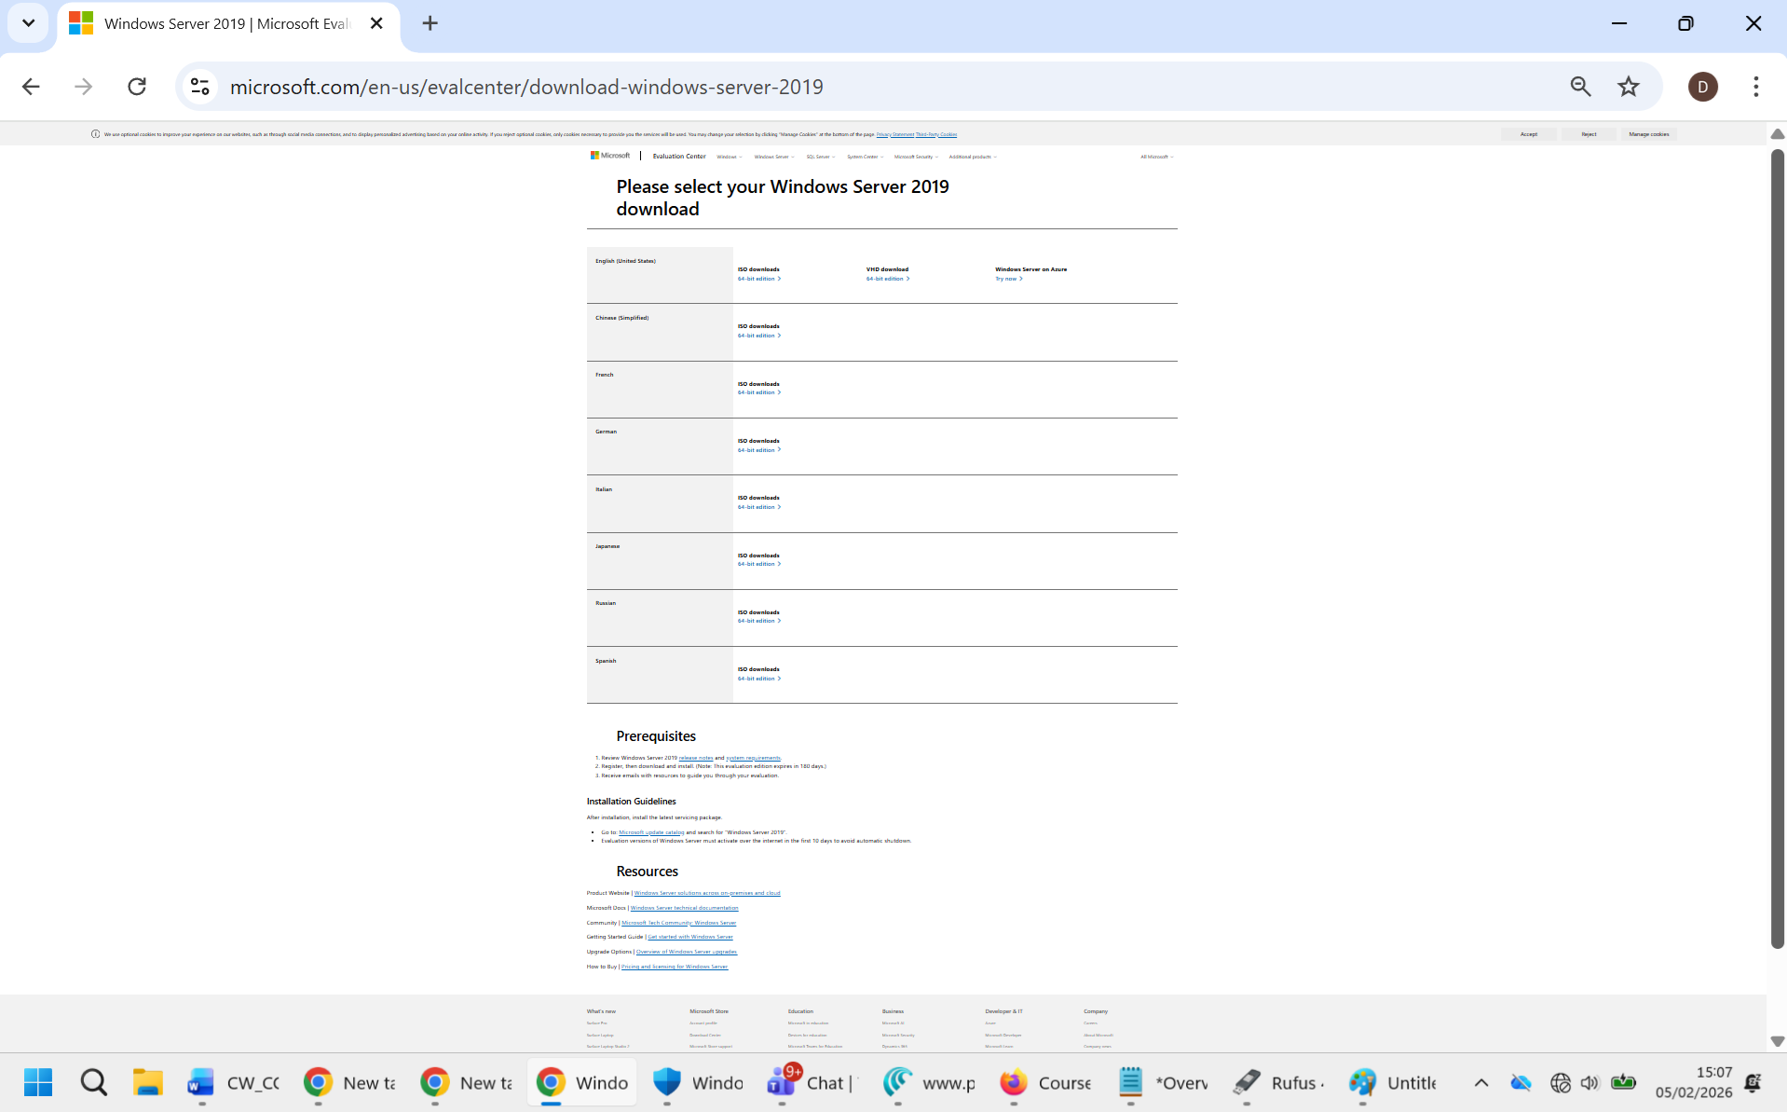  Here is a good example reporting on a cookie related message  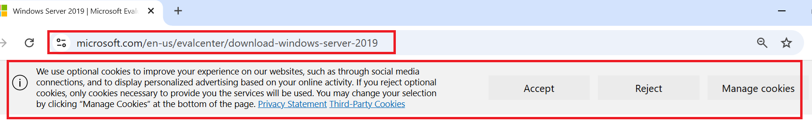  Figure 1  Hosts Affected  10.10.11.199  Recommendations  Recommendation here no more than 15 lines.

Task 2 [10 marks]
During a build review one of your colleagues acquired the following evidence but did not have time to write up the actual issues (there are two issues). Your task is to write up these issues using the template from Task 1. Hint: These are low rated issues.

/etc/profile
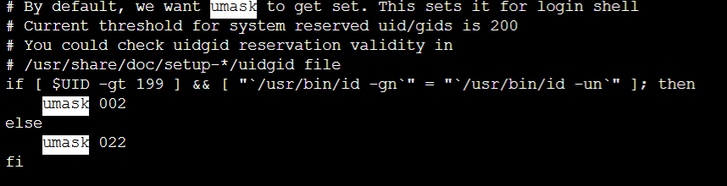

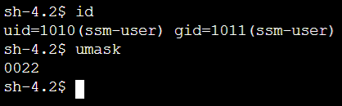

Task 3 (70 marks)
As part of this engagement, you are to conduct a full penetration test on a live environment. Please refer to the following scenario details as to assess the security of these systems.
Assessment scope: 192.168.100.0/24
Exclusions/out of scope: 192.168.100.1 - 192.168.100.20
Special notes: No DoS attacks allowed, if you compromise a system during your assessment please inform your lecturer with relevant evidence so that we can reset.
As the environment within scope is accessible only through the isolated COMP1629 penetration testing Wi-Fi network that your lecturer has configured this assessment can only take place onsite. The Wi-Fi is operating in the vicinity of KW104 for students of COMP1629 only and depending on the sensitivity of your Wi-Fi network card, the environment within scope for this assessment could potentially be accessed across multiple locations within the King William building, the closer you are to KW104 the better the signal and connection speed will be.

What you need to connect, access and assess is a device with wireless connectivity capabilities situated near KW104 (e.g. be just outside in the general lab, or downstairs or even outside assuming you have a strong enough signal).

The device you use will need to have penetration testing tools that allow to assess, scan, test the environment. At a minimum an up-to-date installation of Kali Linux will suffice. This can be installed directly on your device, or it could run as a Virtual Machine.

Once connected to the Pen_Test_WiFi you should be allocated an IP addressvia DHCP in the range of 192.168.100.0/24.
Note: The COMP1629 Wi-Fi is managed by your lecturer so the IT helpdesk/IT support cannot provide any information details etc. All you need is provided in this document. Any further questions ask your lecturer.

The Wi-Fi key which is: studentofsecurity
Note: No spaces, all lowercase.
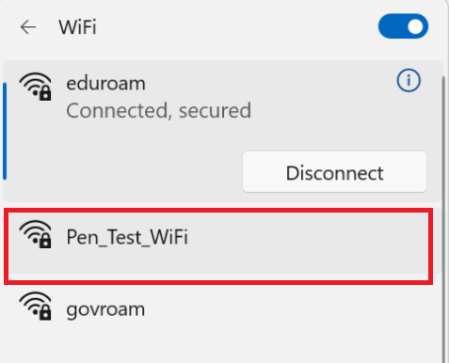

For some of the systems within scope hacking in/gaining access might be as simple as compromising a weak password or a service that can be compromised or might be completely open to access. For other systems it might require more time/effort.

It is up to you to decide the appropriate test approach and how much time to spend on it, based on what we have discussed in class about a full penetration test.

You can use any tools you like to perform this full penetration testing engagement and you should take screen captures while accessing the system assessed (not later but while you do it) as this is the evidence that you will be reporting on.

The evidence must identify you (e.g. you leave a text file in the desktop of the system you have gained access to with your name and screen capture it).
Make sure you configure your system to have your name displayed for any screen captures (Linux setting that you might want to research how to enable).
You will need to provide evidence of the MAC address of the Wi-Fi card used to connect to perform the assessment. This evidence should clearly show the assigned MAC address, IP address, the date, the time and name of your connected account. Your machine’s details will be matched to the logs on the server to confirm access and timeframes.
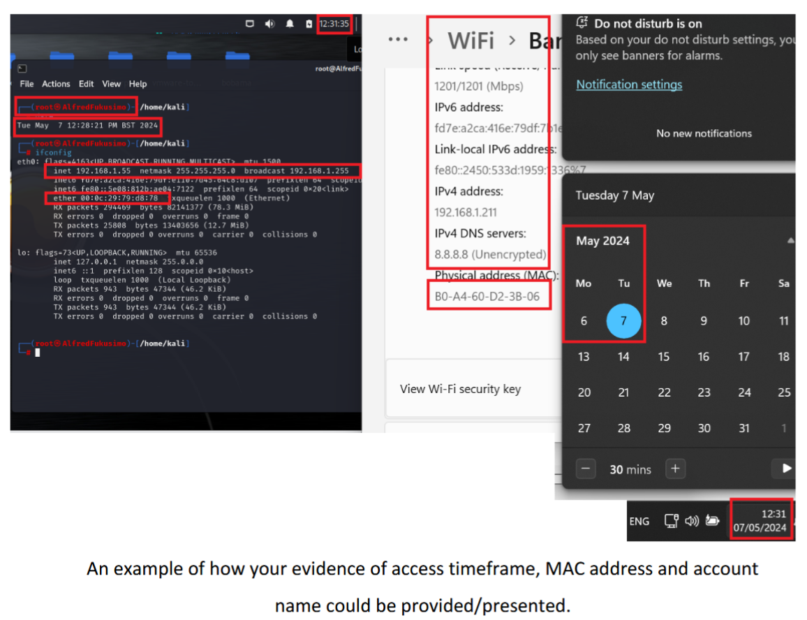

Reporting: When preparing Task 3 of this assessment, you should consider both the reporting requirements and how you intend to document your work (you may use any reporting template you prefer). As you are responsible for managing, conducting, and reporting on the penetration test, you have full control over the content and structure of the report.
For this coursework a professionally completed technical report is required and must include at a minimum the following sections:
- Executive Summary
- List of Identified Issues, ranked by severity based on CVSS scoring
- Detailed Technical Analysis for each issue, organised by criticality

Note: Automated vulnerability tool output (e.g. Qualys, Nessus, OpenVAS can be used for verification/result validation but not for reporting.

For each issue, similar to Task 1, you should provide a concise description explaining the vulnerability, its potential impact, recommended mitigation or remediation measures, and relevant references or best practice guidance.

Relevant cropped/ appropriately targeted/highlighted evidence must be included (make sure that the evidence clearly show that this is from your system).

Technical reporting must follow and adhere to the standard expected for a Penetration Testing assessment report (as discussed repeatedly during the course).

Deliverables
Task 1,2 & 3: A completed professional technical report based on the template that was provided by your lecturer.

Assessment criteria
Task 1 [20 Marks]
Task 2 [10 Marks]
Task 3 [70 Marks]

Marks may be deducted for:
Lack of technical depth, poor presentation, lack of tables, screen captures that do not provide adequate information or with relevant sections not highlighted as needed, screenshots that are not cropped appropriately, poor tool options, poor tool output explanation, poor recommendation, lack of professionalism in the answers provided, poor spelling/grammar, lack of integration/poor flow, poor references/appendices.

Marks will be awarded for:
Completeness, good technical content and depth and good report writing (including good use of English). Please make sure that you proofread your work. An appropriate professional report structure and presentation is expected.

Grading Criteria
+70%: An excellent report (complete) answering all questions, demonstrating an understanding of the concepts and with an excellent conclusion.
+60%: A good report (complete), answering all questions, showing some understanding of the concepts and with a good conclusion
+50%: A reasonable report (complete), answering all questions and with a conclusion
+40%: Report mostly complete, most questions answered and showing only a basic understanding of the concepts
+30%: Report incomplete, or demonstrates little or no understanding of the concepts poor conclusions

